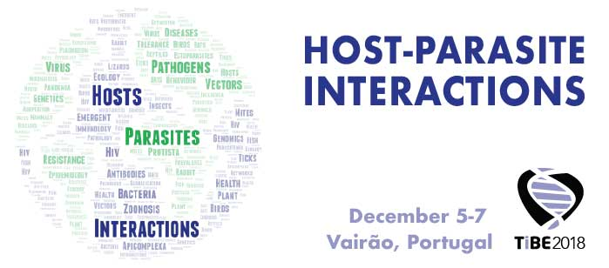

The conference will accept contributions by registered participants in two formats:
- ORAL PRESENTATIONS will consist of 15 minutes presentation followed by 5 minutes for discussion.
- POSTERS will be displayed in panels (format 120 cm high x 80 cm wide), discussed in poster sessions and presented in a 1 min-flash talks in the auditorium (poster in PDF format displayed in the background)

Once your abstract is ready, name your file as SURNAME1stAUTHOR_O for oral communications and SURNAME1stAUTHOR_P for posters and send it to tibe@cibio.up.pt. Deadline for abstract submission is October 15th. Abstract acceptance will be communicated by e-mail by October 30th.
Please follow the following template to submit your abstract:
Title of the presentation

Name A Surname A ¹, Name B Surname B ², Name C Surname C³

¹Department W1, University X1, City Y1, Country Z1
²Department W2, University X2, City Y2, Country Z2
³Department W3, University X3, City Y3, Country Z3

author’s e-mail

MAXIMUM 250 words Abstract text abstract text abstract text abstract text abstract text abstract text abstract text abstract text abstract text abstract text abstract text abstract text abstract text abstract text abstract text abstract text abstract text abstract text abstract text abstract text abstract text abstract text abstract text abstract text abstract text abstract text abstract text abstract text abstract text abstract text abstract text abstract text abstract text abstract text abstract text abstract text abstract text abstract text abstract text abstract text abstract text abstract text abstract text abstract text abstract text abstract text abstract text abstract text abstract text abstract text abstract text abstract text abstract text abstract text abstract text abstract text abstract text abstract text abstract text abstract text abstract text abstract text abstract text abstract text abstract text abstract text abstract text abstract text abstract text abstract text abstract text abstract text abstract text abstract text abstract text abstract text abstract text abstract text abstract text abstract text abstract text abstract text abstract text abstract text abstract text abstract text abstract text abstract text abstract text abstract text abstract text abstract text abstract text abstract text abstract text abstract text abstract text abstract text abstract text abstract text abstract text abstract text abstract text abstract text abstract text abstract text abstract text abstract text abstract text abstract text abstract text abstract text abstract text abstract text abstract text abstract text abstract text
abstract text abstract text abstract text abstract text abstract text abstract text abstract text.

poster/oral presentation
session 1/2/3/4

Notes Underline the author’s name that will present the contribution
Do not include addresses, only affiliations

